Project 2: Wumpus world

1. **Detail information:**

|  |  |
| --- | --- |
| **Name** | **ID** |
| Hà Thế Hiển | 18127097 |
| Khưu Vĩ Luân |  |

1. **Assignment plan:**

|  |  |
| --- | --- |
| **Task** | **Participants** |
| Graphic | 18127097 |
| If in fuction logic |  |
|  |  |
|  |  |

1. **Environment: python IDLE**

Lib :

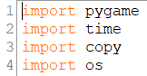

1. **Run the program:**

Run .py or .exe file

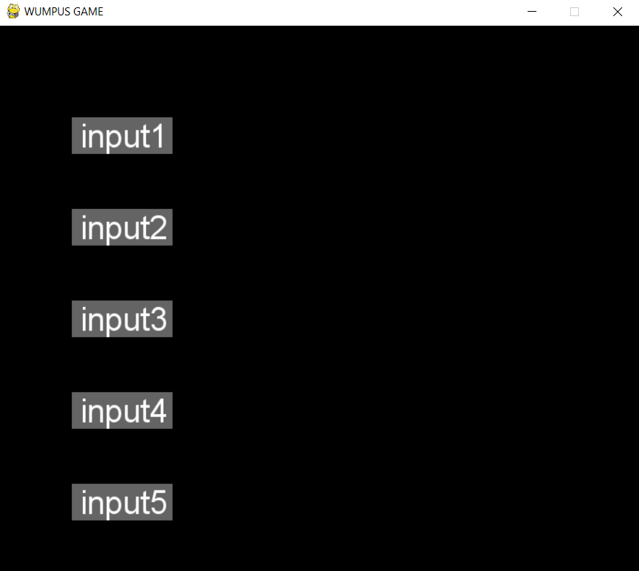

Input is appended from map folder

Chose input to run

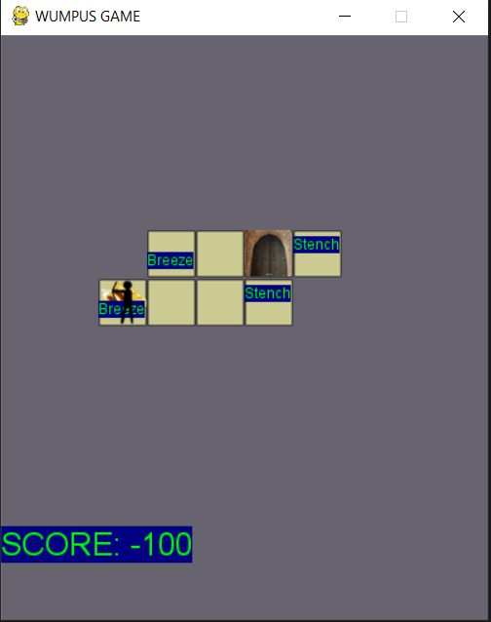

Cmd will print new clause, action A(left), D(right), W(up), S(down) included rotate and move

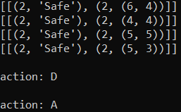

1. **Estimating the degree of completion level for each requirement: Complete**
2. **References:**

<https://github.com/jdebr/AIProjects/blob/9f5ae96d810eee52df36e60dcabc94469d3c08a4/Project2/src/Main.py>

1. **Report your algorithm, experiment with some reflection or comments.**

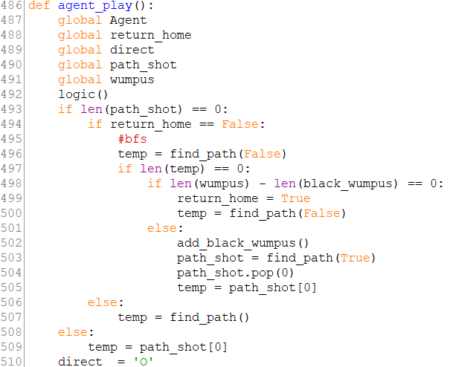

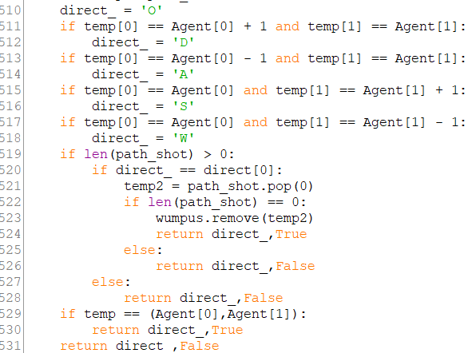

This function will run from data from KB of function logic(), algorithm

Step one: Run all cell can go with BFS(find_path function).,

Step two: If no way to gone, agent hunt Wumpus with BFS(find_path function). It not hunt Wumpus have 4 cell around is Stench (Black_wumpus function). If new cell can go, go to step one.

Step three: find path and return cave(find_path function).

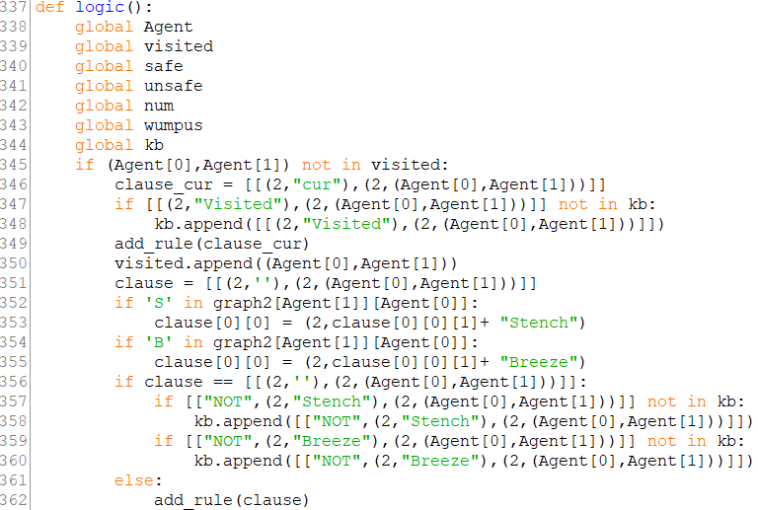

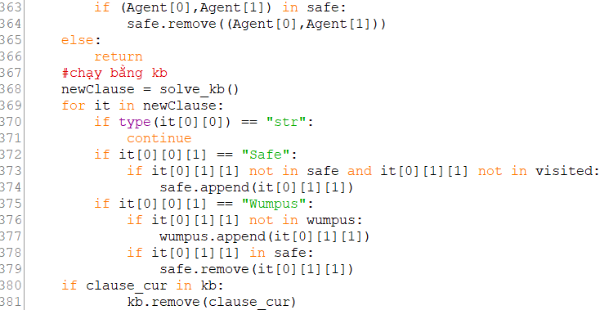

And state “visit” “Breeze” “Stench” “Not Stench” “Not Breeze” “cur” of current agent cell to KB. If this cell in list visited, function will return. Main misson of this function is add clause to KB

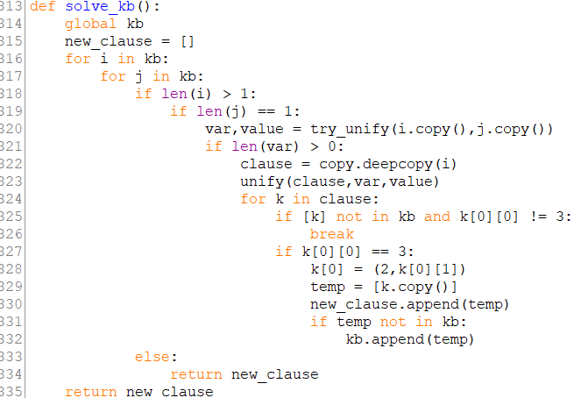

**Form of KB** is: condition -> result

Condition and result is sequence of clause. Eg: a and b and c and …



From the picture above, if the number is 2 then it is clause in condition clause

If the number is 1 then it can unify (it unify one tuple(x,y))

If the number is 3 then ii it is clause in result clause

**Init KB:**

From line 595 to line 626 in function play

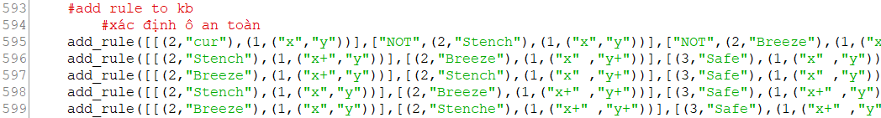

Include: specify safe cell, wumpus cell clause and clause not move wrap around map